/* Ashok IPBC SQL Transactions Lab 7.18.19*/

Homework –

Create a Stored Procedure that accepts StockName, NewOpenPrice, NewClosePrice.

a. If the Stock Name does not EXIST a new record should be added into the dbo.Stocks table

b. If the Stock Name does EXIST, the OpenPrice an ClosePrice will be updated with the newly

inserted Prices.

c. Insert and Update statements should be built using a transaction (Repeatable Read Isolation

Level)

d. A Try Catch Statement should be used for the Update and Insert statements. If there is an

error, the dbo.error_handler Stored Procedure should be called.

-----------------------------------------------------------------------------------------------------------------------

-----------------------------------------------------------------------------------------------------------------------

**Code for above Question is in separate .SQL file**

-----------------------------------------------------------------------------------------------------------------------

-----------------------------------------------------------------------------------------------------------------------

Video(s) to Submit:

1. SQL BI Interview Questions: SQL – Explain the different ISOLATION LEVELS -- Done

What to Submit:

1. Copy and paste the link to your video(s) as part of your homework.

<https://app.colaberry.com/app/ipbc/videos?user=31221&category=50>

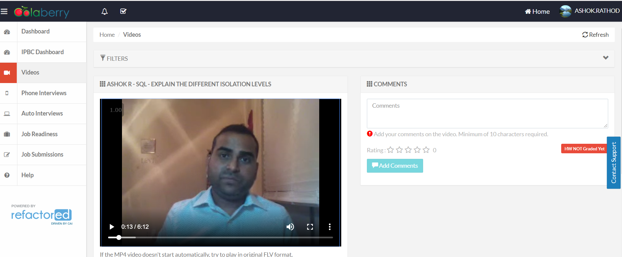

1. Watch, Comment &amp; take screenshots of your comments from 3 other videos on the same topic per question). Comments must be 20+ characters. Leave comments based on presentation, delivery and/or technical details. Your critiques will help you be more conscious of your own videos. (3 comment screenshots per Video Question)

